ServiceNow Assignment:

The application (gurukula) is written in Java and is available at: https://github.com/PA-Reporting/staff
You can launch the application using: java –jar .war
Note: Please use Java 1.8 to access the application. Username: admin Password: admin

Features of the application:
1. The application is used to maintain Branches and Staff information (can be seen from Entities Menu).
2. You can view, edit, delete and query both Staff and Branches.
3. Further, Pagination is enabled when viewing the Staff/Branch.
4. The logged in account information can be viewed/edited from the Account Menu.
5. Login/Logout as existing user
6. Register a new User

What needs to be done:
Please use any language or framework (preferably Selenium) of your preference to automate the various use cases. Upload your automation tests including the defects found and the tests that have not been automated to a Git hub location and share this information when done. Please add information with respect to framework, tests covered, how to launch automation tests and any other information to a document in the same Git hub location.

Application:

The application (gurukula) is written in Java and is available at: https://github.com/PA-Reporting/staff
You can launch the application using: java –jar .war
Note: Please use Java 1.8 to access the application. Username: admin Password: admin

Steps to launch Application:

Step 1: Install Git
Step 2: Go to the Github link : https://github.com/PA-Reporting/staff
Step 3: Download the war file : staff/gurukula-0.0.1-SNAPSHOT.war
Step 4: Launch the Application by executing this in cammand promt: java –jar gurukula-0.0.1-SNAPSHOT.war
Step 5: Below Application will be launched.

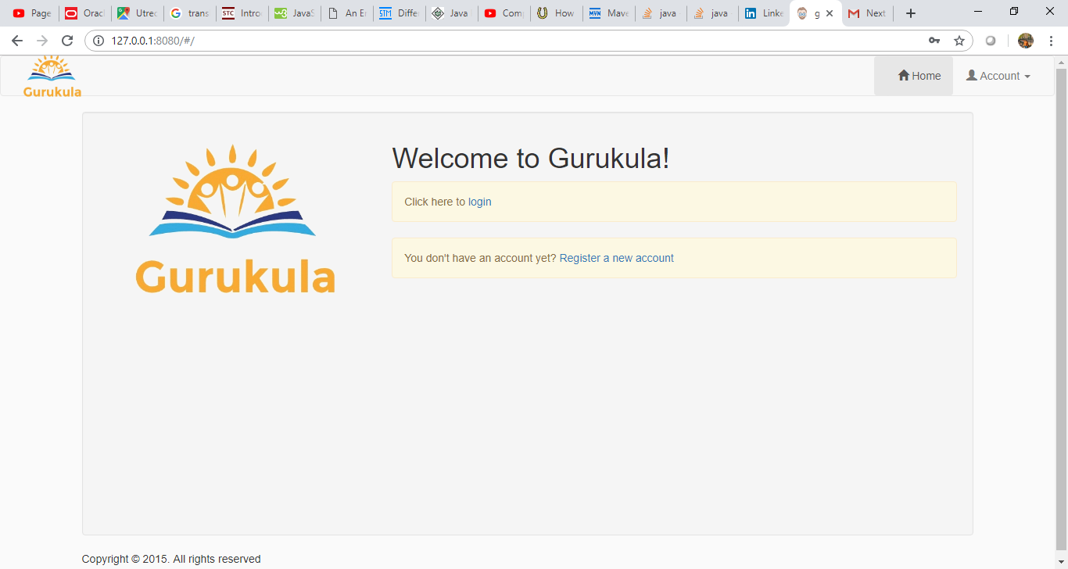

Prequisites configuration for AutomationFramework Used:

1. Install Java 1.8 and JDK 8
2. Install Eclipse for J2E
3. Configure Maven into Eclipse.
4. Add TestNG plugin (install other software from eclipse)
5. Add all dependencies into POM.xml for Selenium and other Jars (Apache POI-all, Logj4, Domj4, Extent Report, Junit, Java mail etc)

Test Scenarios:

1. The application is used to maintain Branches and Staff information (can be seen from Entities Menu).
2. You can view, edit, delete and query both Staff and Branches.
3. Further, Pagination is enabled when viewing the Staff/Branch.
4. The logged in account information can be viewed/edited from the Account Menu.
5. Login/Logout as existing user
6. Register a new User

Test Scenarios/cases are in Data.xlsx embedded here

Hybrid Framework – Data driven + POM model

Procedure for Execution:
1. Copy the Zip file attached to Machine where all the pre-requisites are installed and configured.
2. Execute the test cases under src/test/java /gurukula.qa.testcases

